**Abstract/Project Summary**

# 

We are working on creating a mesh sensor network for use in the agricultural space. The network will consist of nodes wirelessly communicating relevant data with each other and a console. The console collects and displays the data for the user to interpret for use around the agricultural space. The sensor units are equipped with three sensors, a microcontroller, solar panels, and a battery all encased within a weatherproof container for protection against the climate. Each microcontroller can communicate with other sensor units via radio waves to relay information and detect faulty units. One unit alone is responsible for holding all of the units’ relevant information and reporting it to the user’s computer. The units need to be powered for one year.

# **Problem Statement and Deliverables**

Problem Statement: Our network will reduce agricultural waste resource requirements to be decreased by as much as 40%, in turn reducing food cost, and increasing safety for the population as well as producers alike.

The nodes will be encased in such a form that they are at the very least IP43 compliant. It must not let water in for some amount of time and it cannot let dust or small particles get in to interfere with the sensitive electronics inside.

For the network, it is important to establish a protocol to follow for the many cases that may arise. First case is all success. There are no unforeseen complications that arise and the nodes will act as follows: each node starts off in sleep mode, it will receive a wake up call from higher up the line and will go active, it will record data from its sensors, it will also have a look-up table for the node next in line with which it will send data its way, and then whenever it receives information it will send an acknowledgement of the packet received. This will repeat on each node until all data is collected and accounted for. Second case is when a node is faulty. For this case, when the node sends the data it will not receive an acknowledgement and the faulty node will be recorded. The node will then look for the next possible node and report to it instead. Once the data reaches the end of the line, the faulty node will be saved and displayed to the user.

Once all the data has reached the end of the line it is reported to the user via usb on to the users computer. The website, working off of its own localhost, will use the new information provided in order to update the graph so the user can see trends in the farm. This will be done periodically in order to ensure consistent, up-to-date information on the farm.

For power, considering it has to work one year at a minimum, is also powered using solar panels. The solar panels are attached to the case of the node and will recharge batteries whenever it is possible. In order to minimize power consumption, the microcontrollers will also have a wake up/sleep protocol. The wake up/sleep protocol means that each microcontroller besides the gateway will be on a minimum power usage state (asleep) until they receive a wake up call from the gateway. Each node must then work for some allotted amount of time until all of its tasks are completed. The node is then put back asleep until it receives a new wake up call.

**Need for This Project**

The need for this project is not that of an absence of information that is required to produce agriculture post industrialisation. Rather, the benefit presents itself when efficient avenues open for agricultural innovation once localized farm data can be utilized to optimize the growing process. Efficiency in agriculture doesn’t just translate to more money for the producer, it translates to an all-around smarter growing process from farm to table. The potential externalities harvested can decrease agricultural waste that culture bacteria and viral agents around the farm.This is an advantage for protecting both the owners as well as the laborers as a whole. The information will also enable disease prevention in regards to crop protection as much as 40% of crops are estimated to be lost due to disease. This reduced waste and higher volume of marketable production in turn reduces the food cost for the population as a whole.

In regards to the waste of resources, sensor data can reduce water requirements, facilitate crop placement based on light intensity, and monitor air quality and soil pH, which all contributes to a smarter growing process and a higher yield for lower cost. Applications for such analytical data can be applied to the growing process in a myriad of ways. Examples of utilization of this are “Weed Mapping, Variable Spraying, Salinity Mapping '' which are all means to classify and utilize data geographically to improve yields of the agricultural process.

Integrating technology into the agricultural sector does more than just adding efficiency to the process but also creates a single console that farmers can read data from all around their farm. This will help with traveling efficiently around the farm and the 50% of farm workers who report a strain/pain from working in the agricultural space. Environmentally this network has the potential impact to predict and detect land suitability for long term utilization and nutrient retention.

**Visualization**

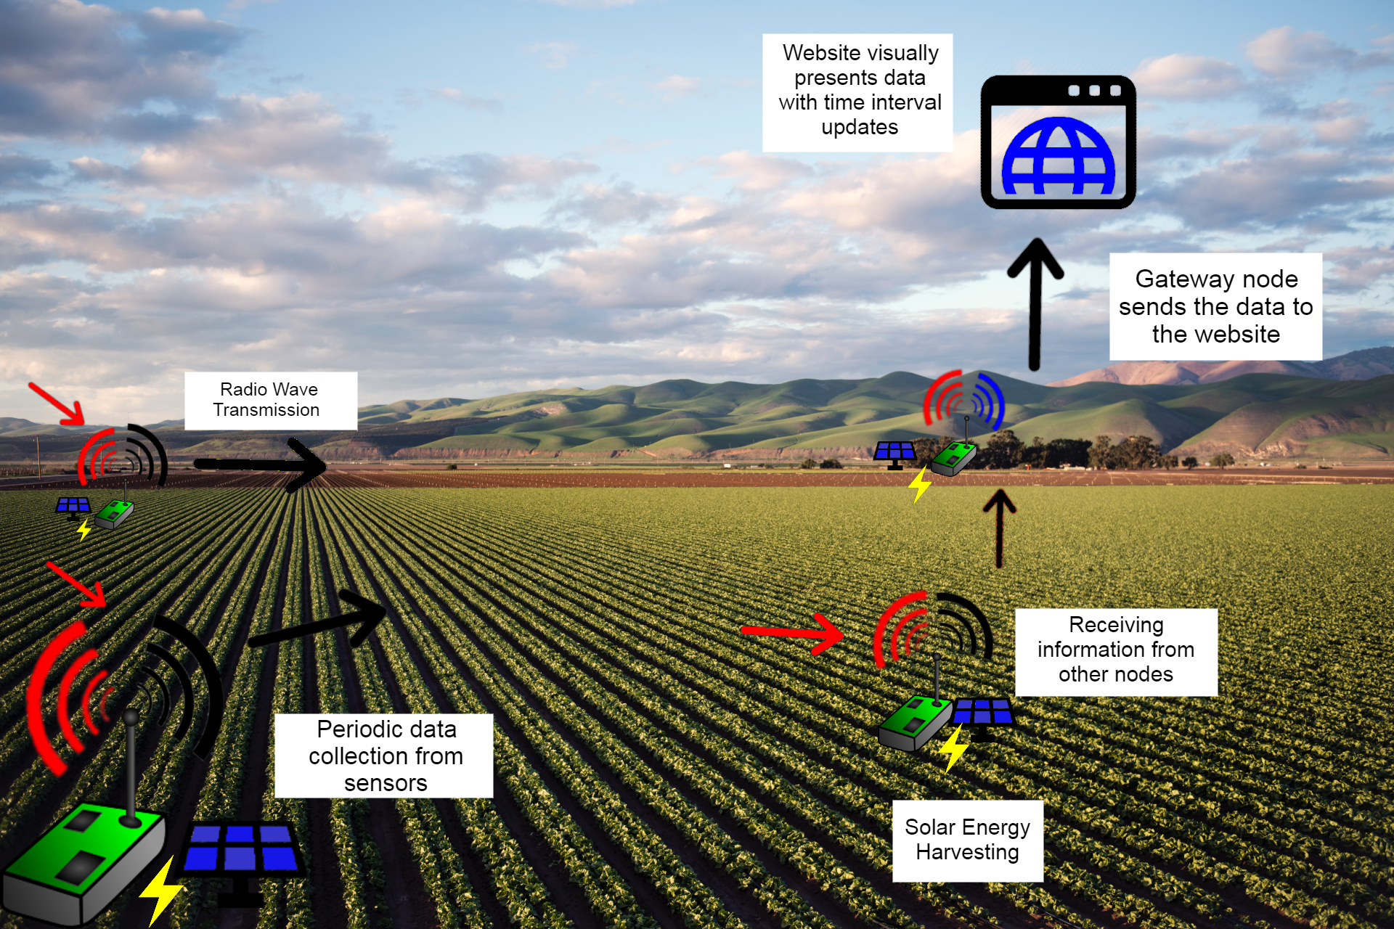

. *Figure 1.1 Displays how the node network would work. Nodes all transmit down the line until all data has reached the Gateway node that reports directly to the website with updated information on the farm*

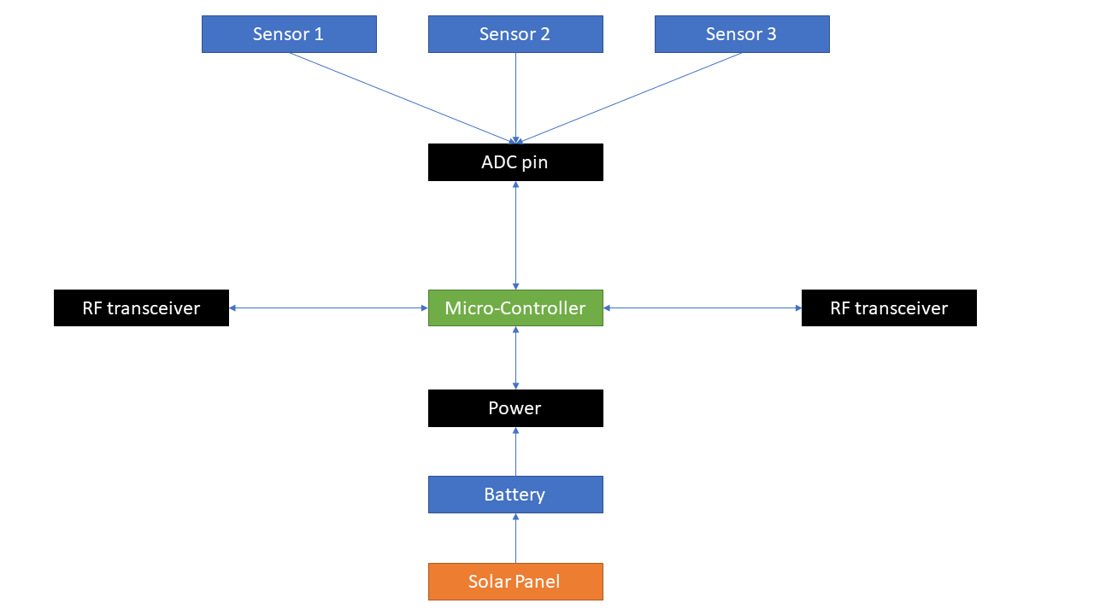

*Figure 1.2 Describes the relationship between all components in each node. All three sensors are wired to the ADC pins which are on the microcontroller. The battery is the main source of energy which can be recharged with a solar panel. The microcontroller is equipped with both an RF transmitter and an RF transceiver to communicate with other nodes*

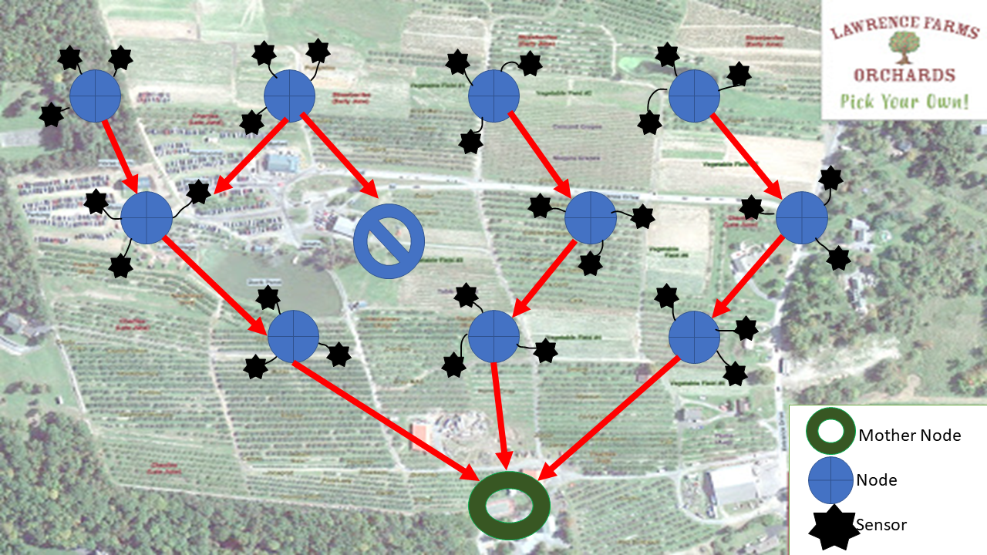

*Figure 1.3 In the case of a faulty node, nodes will settle for the next nearest node. The node that receives the new information will work just as before, it will send its data down the line until it reaches the gateway.*

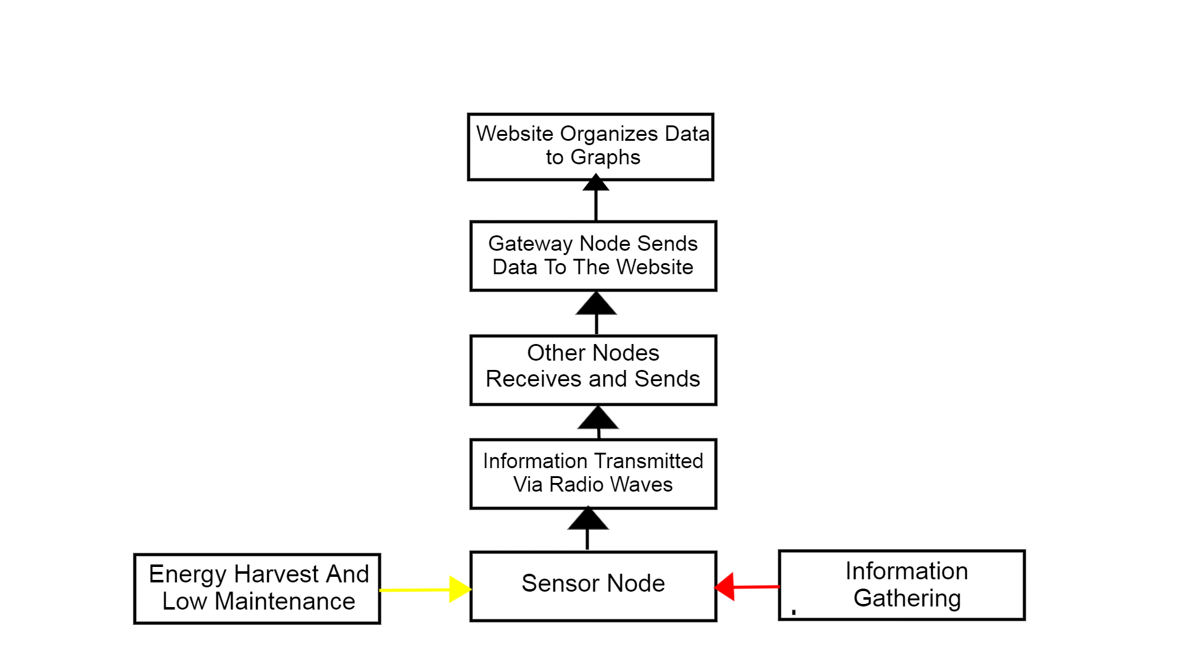

*Figure 1.4 A description of how a single node receives and sends information down the line until it reaches the Gateway and it updates the data on the website.*

The main objective of the project is to have a network of sensors interact with each other by collecting information from their surroundings, sending the data to other nodes, and lastly to have one gateway node to interact with the users computer. As shown in the illustration, the data communication is through radio waves that each node can receive and send to other nodes. The outer nodes illustrate the need of being able to collect sensor data, receive data, and send data while the last node only needs to be able read data and send data via Wi-Fi. The gateway node would gather the information and decode to match time, sensor type, and location. It will have to receive multiple versions of the same data to ensure the robustness of the network. The website would present the information graphically. Each sensor will periodically collect information (humidity, sun light, etc.) which reduces energy consumption. Lastly, the essential part of the project is to power the nodes for one year. We would achieve the requirement through solar energy harvesting and the use of batteries.

**Engineering Requirements (Ben)**

The project visualization is essential to understand and contextualize the essential functions the project must be able to perform, but they must be listed plainly as well to codify them. They are as follows:

* Each node should measure sensor data and send it out to other nodes. Without data collection, the project becomes meaningless, and if the data can’t be sent to other nodes then it can’t be received centrally.
* Each node should be able to listen for incoming data from other nodes. It is essential that data can move throughout the network so that it can be collected.
* The nodes must work together to get the data back to the farmhouse. Working together is key, since if a node is broken and can’t transmit or receive data, that should not interrupt the data flow of other nodes.
* The console must display current and past data from all the nodes. The user should be able to see the data and trends around their farm.
* The console should detect invalid or missing data and which node it came from. If a node is malfunctioning, the user should know which node it is so they don’t have to visit every node on their farm.

There are two key constraints for this project, namely that the cost should not exceed $1000 and that there is no Wi-Fi and limited cell service outside of the farmhouse where this project will be installed. This in effect eliminates the possibility of cloud storage as a means to achieve the functions listed above, hence the emphasis on limited-range node-to-node communication in a mesh network.

The engineering requirements for this project are:

* Each node must be powered for at least a year. Through whatever means necessary, each node must have enough power available to be powered on for at least one year.
* The network should have a node-to-node range of between 750m and 5km. Too short of a node-to-node range would result in many nodes and a complicated network. Too long of a range and the network risks sending its data too far and interfering with other products.
* For 100 sensor readings in identical conditions, the data should be within ±5% of the mean. This is a way to quantify precision. Since the accuracy of the data is limited by the sensors chosen (which are limited by the cost constraint), precision is a more readily improved quantity through engineering design.
* For 100 sensor readings every day for a week, the means should not drift more than ±5%. To further quantify the precision of each node, and to protect the integrity of daily trends, the sensors should be consistent over time.
* Each node must be IP43 compliant or better, meaning that each node needs to withstand 5 minutes of water continuously being sprayed onto it.

**Competing Technologies (Maxine)**

IoT technologies have an ever-growing presence in the agricultural field, so there are products out on the market that do similar things in comparison with what our product is trying to accomplish.

[CleverFarm](https://www.cleverfarm.ag/) is a Czech company that has a range of products to monitor specific areas, such as soil conditions, meteorological conditions, or temperature and humidity sensors for use in enclosed spaces or semi-enclosed spaces such as coops, stables, or silos. Our product aims to combine measurements from the air and soil to provide more information from a single sensor module. All of the CleverFarm modules are solely battery powered. We aim to implement energy harvesting to cut down reliance on battery power and to prolong the amount of time each sensor module can remain in the field without needing any sort of recharging.

[Sensoterra](https://www.sensoterra.com/) is another European company that focuses solely on reporting soil moisture data. Each sensor only communicates with the user, not to the other nodes, so range is limited at around 2.5 km. While Sensoterra sensors boast a battery life of three years, once that three years is up, the sensor node is no longer usable, because the batteries are not replaceable. This creates unnecessary waste, which we will avoid by having our sensor nodes harvest energy and be rechargeable.

[Greenhouse Guardian (Plantect)](https://bosch.io/products/greenhouse-guardian/) is a Bosch product available in Japan and South Korea which is a sensor network designed for greenhouses to measure temperature, humidity, CO2 levels, and solar radiation. All of the sensors connect to a single gateway which then connects to a server for user interaction with the data. Additionally, being an indoor sensor, these sensors aren’t weatherproofed. This is a requirement for our product.

Bibliography

“Almost 40 Per Cent of Worldwide Crops Lost to Diseases,” *The Crop Site*. [Online]. Available: https://thecropsite.com/articles/1202/almost-40-per-cent-of-worldwide-crops-lost-to-diseases/.

“Greenhouse Guardian: Environmental monitoring of greenhouse crops,” *Bosch.IO*, 17-Feb-2020. [Online]. Available: https://bosch.io/products/greenhouse-guardian/.

“Homepage,” *Sensoterra*, 12-Oct-1970. [Online]. Available: https://www.sensoterra.com/.

H. Solidpixels., “We bring innovative solutions to agriculture,” *CleverFarm*. [Online]. Available: https://www.cleverfarm.ag/.